Potemkin Empire
Russia: 1787. Empress Catherine the Great is taking a surprise trip down the Dnieper River to survey her new kingdom. This will take her directly past your old, unremarkable village. You don’t have the time or money to make your village impressive, but with a few pieces of timber and some strategically placed facades you could certainly make your village seem impressive. More impressive, at least, than all the villages around it. What’s behind the riverfront doesn’t matter, after all, only the opinion of her Imperial Majesty.

Overview
In Potemkin Empire, you will play the role of a mayor of a small Russian village. You will attempt to impress Empress Catherine by convincing her that you have the most prosperous and stable village in the land. But with her visit quickly approaching there’s no time to really fix your village so you’re just going to have to make it look as impressive as possible. That is to say, you’re faking it. You’ll accomplish this by drafting interior cards which are either real or fake, then combining them with facades to construct an imposing, if flimsy, kingdom.
You will score points by producing goods in your industrial buildings, exposing opponents’ fake buildings with spies, constructing government and cultural buildings, and passing off fake buildings as real ones. The player with the most points at the end of the game wins!

Contents
1 game board
85 Interior cards
54 Facade cards
40 resource cubes
15 agent meeples
1 capitol meeple
1 scientist meeple
1 shield meeple
5 mode tokens
5 player aids
4 month tokens

Setup
- Set the game board in the middle of the table. Everything on or next to the game board is considered part of the supply.
- Shuffle all of the Interior cards together to make the Interior deck. Place it next to the board where it says “Interior Deck.”
- There are five types of Facade cards: Culture, Espionage, Government, Industry, and Science. Separate them into piles based on type. Place those piles next to the game board on the corresponding spaces.
- Place all of the resource cubes and agent meeples in the corresponding sections of the game board. Place the scientist meeple and the shield meeple in the corresponding spaces on the game board.
- Stack the four month tokens faceup in order so that the token labeled “4” is on the bottom and the token labeled “1” is on the top. Place this stack in the corresponding space on the game board.
- Give each player a player aid and a Mode token. The Mode token shows which actions are available to a player. Each player sets this token to Construction mode and places it in front of them at the top of their play area so that they have plenty of room to construct their village behind this token.
- The player who has most recently interacted with a government bureaucracy is the first player. Place the capitol meeple in front of that player.
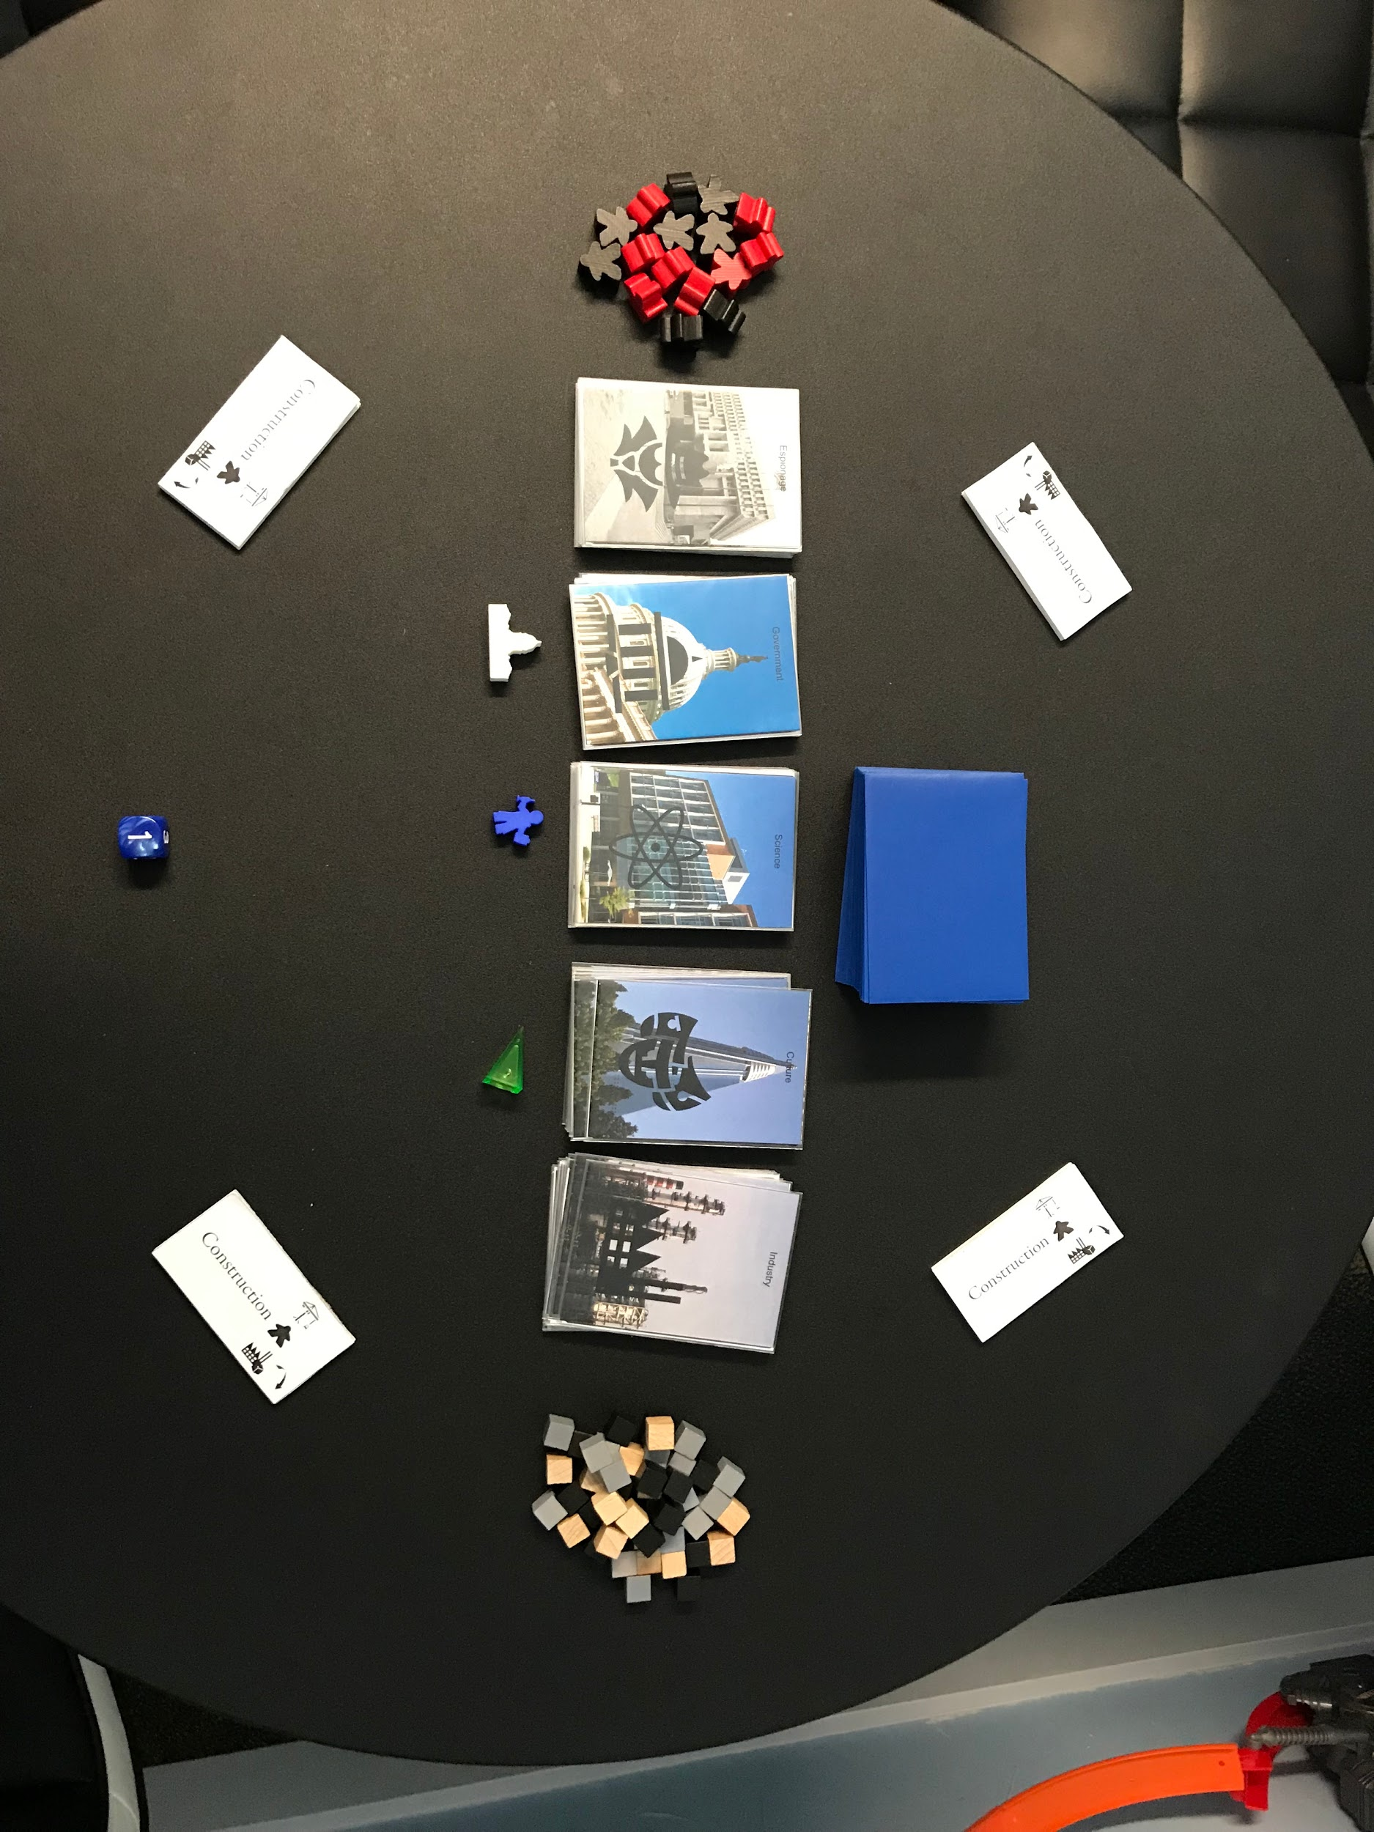
Interiors
Mode token
Façades
Agents
Capitol, Scientist, Culture Shield
Resources
Month

Gameplay
Potemkin Empire is played over four rounds (months). Each month consists of three phases: a Drafting phase, a Action phase, and an End Phase.

Drafting Phase
At the start of the Drafting phase, deal four Interior cards to each player starting with the first player. If the Interior deck is ever empty, shuffle the discard pile together facedown to form a new Interior deck.

Each player drafts an Interior card in secret. Do this by choosing and keeping one card from what you were dealt, then passing the remaining cards in the direction indicated on the month token. For months 1 and 3, it is clockwise. For months 2 and 4, it’s counterclockwise.
Next, choose a card to keep from the cards you were just passed and pass the remaining cards in the same direction. Repeat this until all players have drafted four cards.

Example: 1. Bob is dealt four Interior cards shown below. He chooses to keep the circled card. He places it facedown in front of him on the table. He passes the three remaining cards to Candi on his left. 2. Next, he looks at the three cards Abby passed him. He chooses the circled card and places it facedown on top of the first card he drafted. He passes the remaining two cards to Candi. 3. Then, he looks at the two cards Abby just passed him. He selects the circled one. He passes the remaining card to Candi. He places the last card Abby passes him facedown on the three other cards he chose.

Action Phase

Once the players have each drafted four Interior cards, the Action phase begins. During this phase, players will take turns performing one action starting with the player with the capitol meeple and then continuing in the same direction as cards were passed during the Drafting phase. Players will continue taking turns until only one player is left in Construction mode.

Scientist meeple-If you have the scientist meeple at the beginning of your turn, draw an Interior card from the deck.

Actions
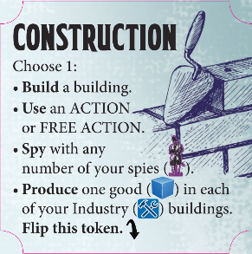
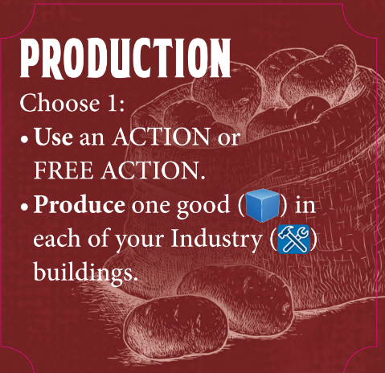
When it is your turn, you will choose one action listed on your Mode token to perform this turn. Players start each Action phase in Construction Mode. There are four types of actions a player can choose while they are in Construction mode: construct a building, play a card ability, spy with agents, and produce resources. Once a player chooses the produce resources action, they will switch into Production Mode where they will only be able to play a card ability or produce resources for the rest of this month’s Action phase.

Construct a Building
When you build, you will choose the type of building you want to build. Stand up a Facade card of the type you chose in your play area so that the back is facing you. Place an Interior card from your hand facedown on the base of the Facade. You must have at least one interior card in your hand to choose this action. When you construct a building, you will not resolve the ability text of the Interior card. You are not allowed to rearrange the Facade or Interior cards in your city.

Facade cards- The Facade card determines the type of the building. All of the Facade cards of each type are identical. There are five types of buildings you can build, each with different effects: Culture, Espionage, Government, Industry, and Science.
- Culture- You will score 1 point for each Culture building in your village at the end of the game. Additionally, after you construct a Culture building, if you have the most or are tied for the most Culture buildings, you gain the shield meeple from the board or from the player who has it. Having the shield meeple helps protect you from spies. For more information, check out the Spy section on pg XX.

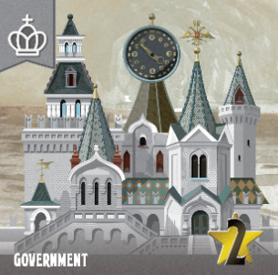
- Espionage- After you construct an Espionage building, place an agent meeple behind it. In a later turn, you can choose the spy action to destroy opponents’ fake buildings. At the end of the game, you will score 2 points for each building you have destroyed. For more information on spying, see the Spy section on pg XX.

- Government- You will score 2 points for each Government building in your village at the end of the game. Additionally, after you construct a Government building, if you have the most or are tied for the most Government buildings, you gain the capitol meeple from the player who has it. The player with the capitol meeple will take the first turn at the start of the Action phase.
- Industry- When you choose the produce action in a later turn, you will place 1 resource in (behind) each Industry building in your village. You will score 1 point for every resource you have in buildings at the end of the game.

- Science- After you construct a Science building, if you have the most or are tied for the most Science buildings, you gain the scientist meeple from the board or from the player who has it. When you start your turn with the scientist meeple, you draw an interior card.

Interior cards determine whether a building is real or fake. There are three types of Interior cards: real, fake, and conditionally real.
- Real Interior cards have “REAL” written on the right side. Buildings constructed with real Interior cards are real buildings.

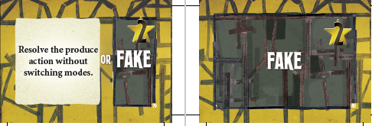
- Fake interiors have “FAKE” written on the middle or right side of the card. Buildings constructed with fake Interior cards are fake buildings.

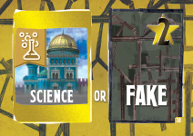
- Conditionally real Interior cards have the image of the building type that would make them real on the left side of the card. Buildings constructed with these Interior cards are real buildings if the Facade card used to construct the building matches the image shown. If the building type does not match the icon, the building is fake.

Example: It is Abby’s turn during the Action Phase. Abby wants the scientist meeple to come to her village so that she can draw extra Interior cards at the start of her turn, so she chooses to construct a Science building. She wants it to be a real Science building so she selects the Interior card shown, which is real if used to construct a Science building. She grabs a Science facade from the supply and stands it up in front of her so that the back is showing. She places the Interior card she chose facedown behind it. Abby now has more Science buildings than any other player, so she places the scientist meeple in her village.
Play a Card Ability
If you have an Interior card with an ACTION: ability, you may use this effect by playing it from your hand. When you do, resolve the ability and place the card in the discard pile. If it is a “FREE ACTION:”, you can play it without it costing your action for the turn. You may play multiple “FREE ACTION:” cards in a turn in this way. You can use an Interior card for its ability or to construct a building, but not both.
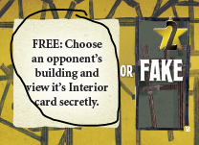
Example: It is Candi’s turn during the Action Phase. She is planning on spying soon because she has two ready agents. She has the Interior card shown in her hand. She plays it and looks at the Science building that Abby just constructed. She sees that it is real, so she knows not to check it with one of her agents. Since that was a FREE ability, Candi now chooses another action to perform this turn.

Spy with Agents
When you choose to spy, you will use any number of your ready agents to check opponents’ buildings to find out if those buildings are real. Agents are ready if they are behind buildings. Once your agent is done spying, it is spent, and you set it in front of your buildings next to your Mode token. All spent agents will be readied during the End phase.

When you spy, place one agent in front of each building you want to check. Once you have placed all of the agents you want, the corresponding Interior cards are revealed.
- If the building is fake, that building is destroyed. When a building is destroyed, the Facade, all cubes, and any agent meeples behind that building are returned to the supply. Additionally, the player spying places that Interior card facedown under their Mode token. At the end of the game, you will score 2 points for each building you have destroyed.
- If the building is real, you place the Interior card face up on the table in front of that building so that information is known to all players for the rest of the game.
There are three special rules related to spying:

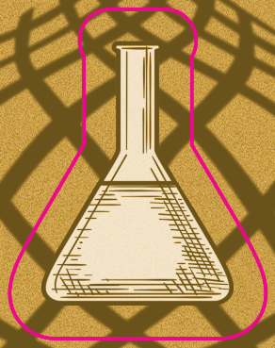
- Shield meeple- The shield meeple provides some protection from spies. Therefore, if you want to spy on a building in the village that has the shield meeple, you must first spend an agent to return the shield meeple to the game board. Otherwise, you cannot spy on an opponent’s building if that player has the shield meeple.

- Scientist meeple- If a building is destroyed in the player’s village that has the scientist meeple, the scientist is scared out of that village, so it is returned to the game board.
- Espionage buildings- The stakes are higher for an agent that spies on an Espionage building. If the building is real, the agent is killed (returned to the supply). If the building is fake, you may immediately use that agent to check on an additional building.

Example: It’s still Candi’s turn. She has decided to spy. She knows Abby’s Science building is real, so she won’t use an agent there. She chooses to check two of Bob’s Industry buildings. Bob reveals the Interior card of the first building. It is real. The Interior card is placed faceup in front of that building for the rest of the game. The Interior card of the second building is revealed. It is fake! Candi places the Interior card under her mode token. It will score Candi 2 points at the end of the game. Bob returns the Facade, and the resource cube behind it, to the supply.
Produce Resources
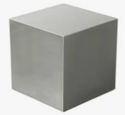
When you choose to produce, place one resource cube behind each of your Industry buildings, even the fake ones. Then, if you were not already in Production Mode, flip your Mode Token to the Production Mode side. After you flip into Production Mode, if there is only one player still in Construction Mode, the Action phase ends immediately.
Example: On Bob’s turn, he chooses to produce. He places one resource cube in each of his three Industry buildings. Then, he flips his Mode Token to the Production side.

End Phase
As soon as there is only one person in Construction Mode, the Action phase ends and the End phase begins. During the End phase, each player:
- Discards any Interior cards they have remaining in their hand.
- Resets their Mode token so that the Construction side is face up.
- Readies all of their spent agents by placing one agent behind each of their Espionage buildings if able. If you have more agents than Espionage buildings, you must place one behind each before placing multiples in any. If you have no Espionage buildings, you may place them behind any of your buildings. If you have no buildings at all, your agents do not ready.
Finally, return the current month token to the box. At the end of fourth month, Catherine the Great arrives, ending the game. Calculate final scores and determine a winner!

End of the game

At the end of the game players total up their points. Players score points in the following way:
2 points for each fake building in their village
2 points for each Government Facade in their village
1 point for each Culture Facade in their village
2 points for each Interior card under their Mode token. These are the buildings they destroyed during the game.
1 point for each resource cube behind buildings in their village

The player with the most points wins. Catherine invests a fortune into your village to make it the most beautiful and productive city in the country.
If there is a tie, the tied player with the most fake buildings wins. If there is still a tie, the player closest to the capitol meeple in turn order wins.

Action Overview

➤ If the Scientist is in your City, draw one additional Interior card from the deck before taking an Action.
Action | Effect
Build: | Choose what building type you are constructing by combing one Facade card with an interior card in your hand and place them in your play area.  Announce that your new building is “Definitely real” so everyone knows what an honest player you are. (See Construct Action on page XX for more info.)  Note: an Interior is used as a building OR for its Card Action, not both.
Spy: | Use any number of your ready agents to check on opponents’ buildings by placing them in front of the buildings you want to check. Then, resolve each agent one at a time. Fake buildings are returned to the supply. You keep the interior card under your mode token to score 2 points at the end of the game. Real buildings are revealed for everyone to see.  (See Spy Action on page XX for more info.)
Produce: | Place one Resource behind each of your Industry buildings. If your City was not already in Production Mode, flip your Mode Token to “Production”.  (See Produce Action on page XX for more info.)
Use an ACTION Ability | Play an Interior card with an ACTION or FREE ACTION ability from your hand. Resolve the ability and place the card in the discard pile. If it is a “FREE ACTION:”, you can play it without it costing your action for the turn. You may play multiple “FREE” cards in a turn in this way.  Note: An Interior is used as a building OR for its Card Action, not both.  (See Use an ACTION Ability on page XX for more info.)
While in Construction Mode, available actions are: Build, Play a Card, Produce, and Spy.
While in Production Mode, available actions are: Play a Card and Produce.

Once in Production Mode, it is impossible to return to Construction Mode during the Month. You only switch back at the beginning of the next Month.

Credits
Game Design: Jonathan Woodard
Game Development: Nick Little and Brian McCarthy
Illustrations: Константин Подгаец
Graphic Design: Daniel Solis
Editor: Rachael Mortimer

Playtesters: Rafael Rosario, Heather Newton, Shane Upchurch, Ari Upchurch, Andrea Steffes, Ron Woodard, Chris Sellers, Jacob Roberson, Shannon McDowell, Joe Hopkins, Joshua Sprung, Bruce Bielawa, John Eakins, Shaun Cranford, Kit Burgess, Fletch Brown, Adam Urness, Kim Urness, Eli Kuhlmann, Diane Friedman, Chris Blackthorn, Nathan Lubchenco, Alejandro Soto, Marshall Hayes, Andy Stone, Andrew Flynn, Ben Roberts, Daniel Reifenberger, Zach Hoekstra, Neil Edwards, David Hoffman, Graham Wilson, Ryan Laney, Caleb Hanson, Austin Baker, Ryan Wanger, James F. Barry, Justin Larrabee, Katie Carr, Alex Ruslan, Denver Prototopia, Jon Zierden, Sydney Engelstein, and the awesome attendees at Geekway to the West 2018

